PRODUCT INVENTORY MANAGEMENT

Project design
Phase solution architecture

Date | 07-03-2026
Team ID | SWTID-2026-5992
Project Name | Product Inventory Management / Aura Inventory
Maximum Marks | 2 Marks

Proposed Solution:

The proposed solution is a robust backend system built using Node.js and Express.js. It provides secure REST APIs for product inventory management.

Database: MongoDB is used for scalable data storage.
Architecture: Follows the MVC (Model-View-Controller) design pattern for better code maintainability.
Security: Integrated with JWT (JSON Web Token) for authentication and middleware-based authorization.

System Features (Functional Modules):

Authentication Module: Handles User Registration and Login. It issues a JWT token upon successful login.
Inventory Module (CRUD): * Create: Add new products with details (Name, Price, Quantity).
create: Fetch the list of products belonging to the logged-in user.
Update: Modify existing product information.
Delete: Remove products from the database.
Security Middleware: Intercepts every request to verify the user's identity before accessing the database.
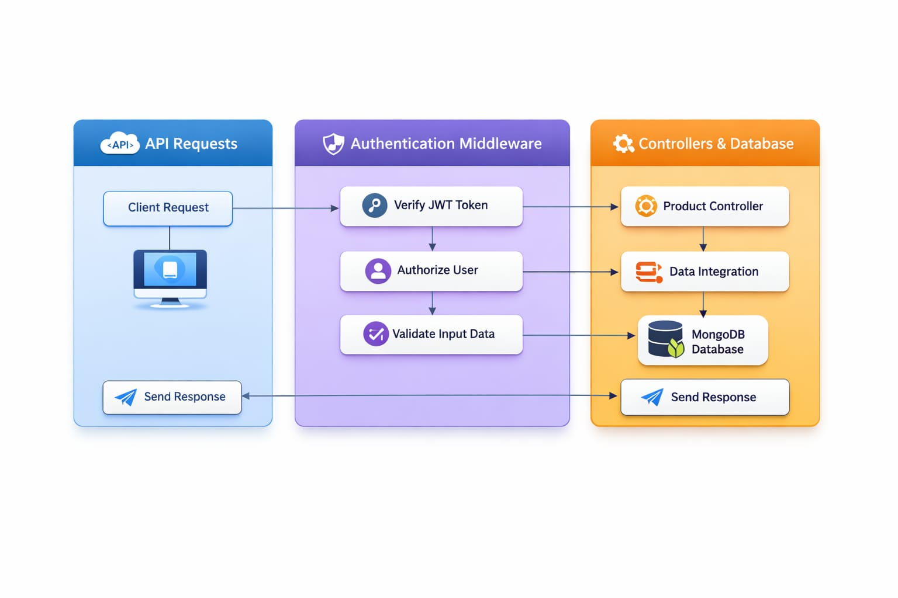
API Endpoints Table:

S.No | Method | Endpoint | Description
1 | POST | /api/auth/register | Creates a new user account.
2 | POST | /api/auth/login | Authenticates user and returns a JWT token.
3 | GET | /api/products | Retrieves all products for the authenticated user.
4 | POST | /api/products | Adds a new product linked to the user's ID.
5 | PUT | /api/products/:id | Updates details of a specific product.
6 | DELETE | /api/products/:id | Deletes a specific product from the inventory.

Social Impact & Customer Satisfaction:

This system empowers small-scale vendors and individual sellers by providing a professional-grade inventory tool without the need for expensive software. By ensuring data privacy and reliability, it builds user trust and helps businesses operate more efficiently.

Visual Workflow Summary (For your report):

Step 1: User → Login Request → Server.
Step 2: Server → JWT Token → User.
Step 3: User → Request + Token (e.g., Get Products) → Middleware.
Step 4: Middleware → Validate Token → Controller.
Step 5: Controller → MongoDB Query (Filtered by User ID) → Database.
Step 6: Server → JSON Data → User.

